Ideation Phase
Define the Problem Statements
Date | 18 june 2026
Team ID
Project Name | HOUSE RENT
Maximum Marks | 2 Marks

Customer Problem Statement Template:
As a customer looking to buy or rent a house, apartment, or property online, I want to easily search, compare, and explore available properties in one platform so that I can find a suitable property quickly and conveniently. However, it is often difficult to access complete property information, compare multiple listings, and communicate with property owners efficiently because traditional property-hunting methods require significant time and effort. This makes me feel frustrated and overwhelmed when trying to make housing decisions.
Solution Provided by HouseHunt
HouseHunt addresses this problem by providing:
- A centralized property listing platform
- Property search and filtering features
- Secure user authentication and authorization
- Detailed property information with images
- Property categorization based on type, location, and price
- Property inquiry and communication system
- User profile management
- Admin dashboard for efficient property and user management
- Property status management (Available, Sold, or Rented)
- Responsive and user-friendly interface
This enables users to browse, compare, and explore properties easily while helping property owners and administrators manage listings efficiently. The platform simplifies the property search process, improves accessibility to property information, and enhances communication between potential buyers, tenants, and property owners.
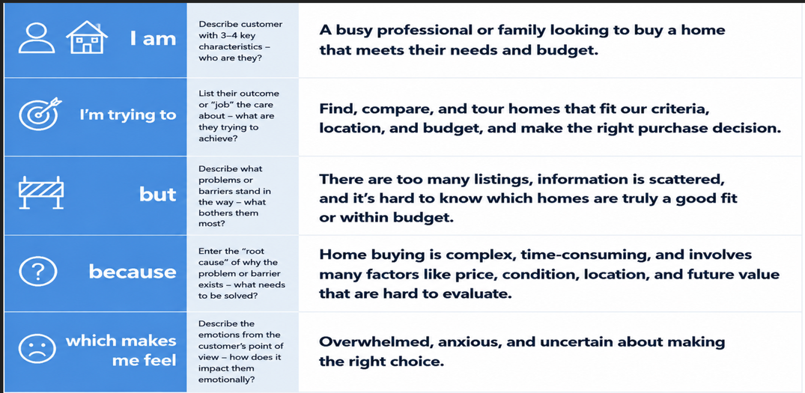
Reference: https://miro.com/templates/customer-problem-statement/
Example:
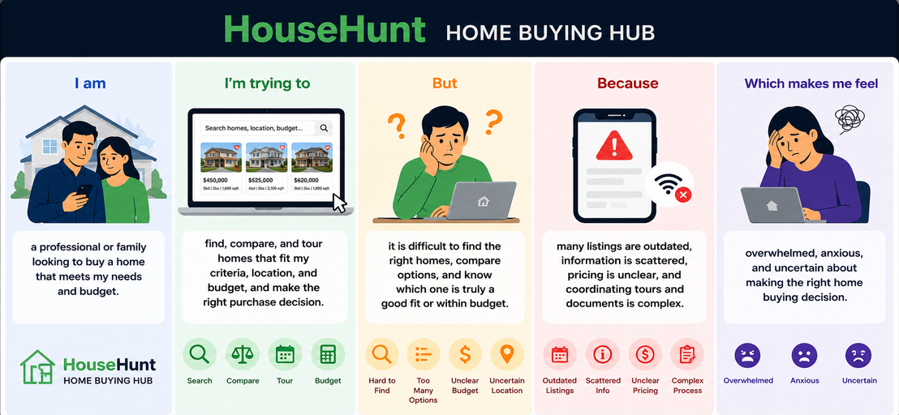

Problem Statement (PS) | I am (Customer) | I'm trying to | But | Because | Which makes me feel
PS-1 | A user looking for a house | Find a suitable property quickly | It is hard to find all listings in one place | Property information is scattered across multiple sources | Frustrated
PS-2 | A user planning to buy or rent a property | Compare properties before making a decision | Many platforms lack effective search and filtering | Important property details are often incomplete | Confused

